Anthony Redamonti

Syracuse university

Homework 5

CIS-623 structured programming & formal methods

prof. Mehmet kaya

2/17/2022



Question 1:

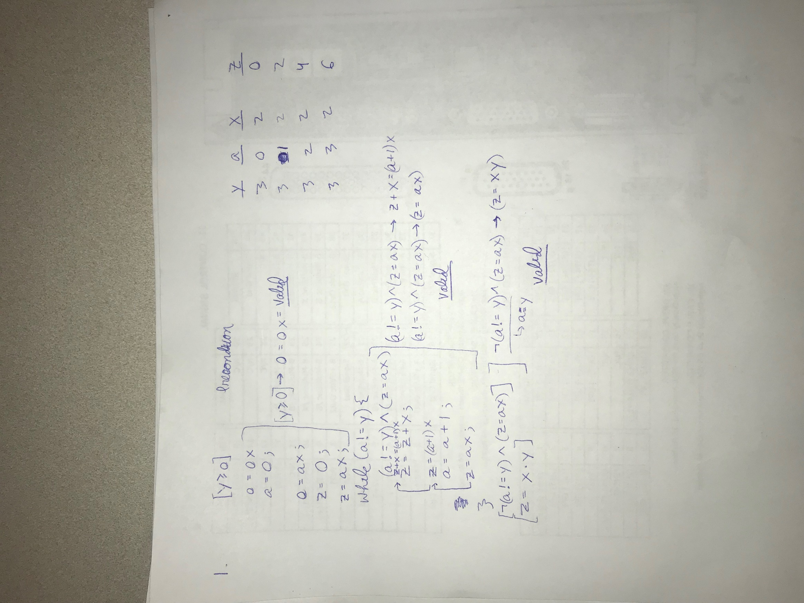

Question 2:

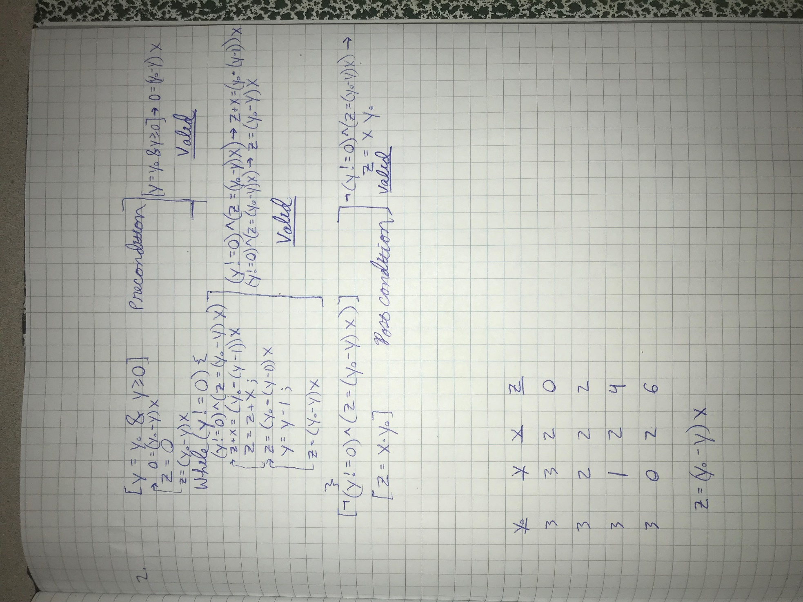

Question 3:

